

System Design Standards

**Copyright © 2017 by OptumRx. All rights reserved.**

**No part of this publication may be reproduced, transmitted, transcribed, stored in a retrieval system or translated into a foreign language without the written consent of OptumRx. If disclosed in writing or other tangible or electronic form, the information must be conspicuously labeled at the time of delivery as “Proprietary Information” or “Confidential Information”.**

**Any request can be made by contacting OptumRx at:**

Corporate Headquarters:

Table of Contents

1 Introduction 5

1.1 About this Guide 5

1.2 Example Look and Feel 5

2 Screen Design 7

2.1 Screen Types 7

2.1.1 Menu 7

2.1.2 Select 8

2.1.3 Detail 8

2.1.4 Pop-Up 9

2.1.5 Copy/Merge 9

2.1.6 Confirm Prompt 12

2.1.7 Multi-Line Display 12

2.2 Colors 13

2.2.1 Screens 14

2.2.2 Menus 15

2.2.3 Screen/Program Naming Convention 15

2.3 Options 16

2.4 Functions 21

2.5 Headers and Titles 24

2.5.1 Screen Headers 24

2.5.2 Column Headers 24

2.6 Fields 26

2.6.1 Common Rules 26

2.6.2 Numeric Fields 27

2.6.3 Date Fields 28

2.6.4 Record IDs 29

2.6.5 Message Code/Type 30

2.6.6 Multi-Page Screens 32

2.6.7 Sort/Positioner Fields 34

2.6.8 Audit Fields 34

2.6.9 Copy/Merge Screen Fields 35

2.6.10 Multi-Source Codes 35

2.6.11 Add Record Count 36

2.6.12 Status Fields 37

2.6.13 Report Fields 38

2.6.14 F1 Help Text 38

2.6.15 Field Validation 39

3 Program Behavior 41

3.1 Search Behavior 41

3.2 Selecting and Auditing Records 43

3.3 Deleting Records 43

3.4 Copying Records 43

3.5 Selecting Records 43

4 Messages 46

5 Spelling 47

6 Trademarks 48

7 Document Change Log 49

# Introduction

## About this Guide

The goal of OptumRx “green screen” system design standards is to maintain a common look and feel for all screens and task behavior that is consistent with an AS400 interface. Since this document demonstrates standards for screen and menu colors, it is recommended that readers either print this document on a color printer or view it on a color computer monitor

## Example Look and Feel

The following annotated screen provides an example of the common elements consistent with the default appearance and behavior for screens developed by OptumRx:













These common elements are described below:

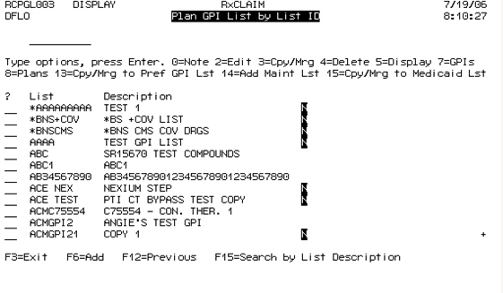









|  |  |
| --- | --- |
| **Element** | **Description** |
| **Screen Header** | All screens include two lines of header at the top that includes program ID, screen mode, system name, system date, user ID, screen title, and system time. |
| **Search Field** | Most select screens include a search field that helps the user find the record they want. Search field(s) is always placed below the screen header and above the record options. Depending on the nature of the fields displayed, select screens may have one or several search fields. |
| **Available Record Options** | Select screens include numbered record options that the user applies to an individual record in the records list. These options are placed above |

|  |  |
| --- | --- |
| **Element** | **Description** |
|  | the record list and below the search field(s). |
| **Record Option Select Field** | Users perform tasks on specific records by typing an option code in the field next to the appropriate record in the list. The selection field is always displayed to the left of the record under the “**?**” column header. Developers size this field (one or two characters) depending on the number of digits in the available record options. |
| **Functions** | Similar to options, function keys control specific tasks. This includes tasks that require navigation to previous screens, adding records, and alternative search options. |
| **Record List** | On a select screen, the system displays a set number of records with a pre-designed number of fields and associated column headers. |
| **Multiple Page Indicator** | A plus sign (“+”) indicates any screen that requires scrolling. This applies to select screens, in which scrolling displays the next set of records, and multiple page detail screens where scrolling displays the next screen of detail in the series. A user scrolls the screen by pressing the **Page Down** key. |

# Screen Design

## Screen Types

Although developers can design screens many different ways, there are a few standard screen types that make up the bulk of screens used in OptumRx systems. By following system standards when designing these screens, developers can maintain a common look and feel across all OptumRx systems. The basic types of screens that developers can use for OptumRx systems include menu, select, detail, pop-up, copy/merge, and confirm prompt.

### Menu

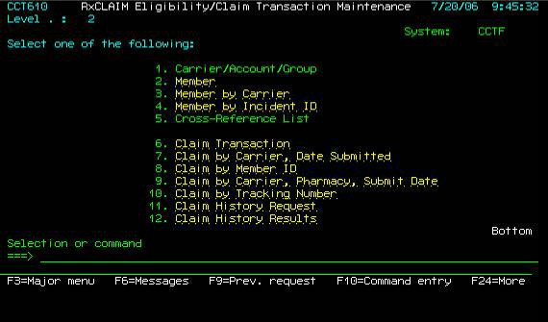

Menu screens provide the primary navigation method for OptumRx systems. Each menu item is assigned a corresponding number. Users select menu items by typing the menu number on the command line and pressing **Enter**.

There are two types of menu items, indicated by the menu item’s color. Green menu items link to a sub-menu. Yellow (amber) menu items link to data screens (select, detail, etc.) In the example shown above, menu items **1** and **5** are green, indicating that they link to the sub-menus **Carrier/Account/Group** and **Cross- Reference List** respectively.

### Select

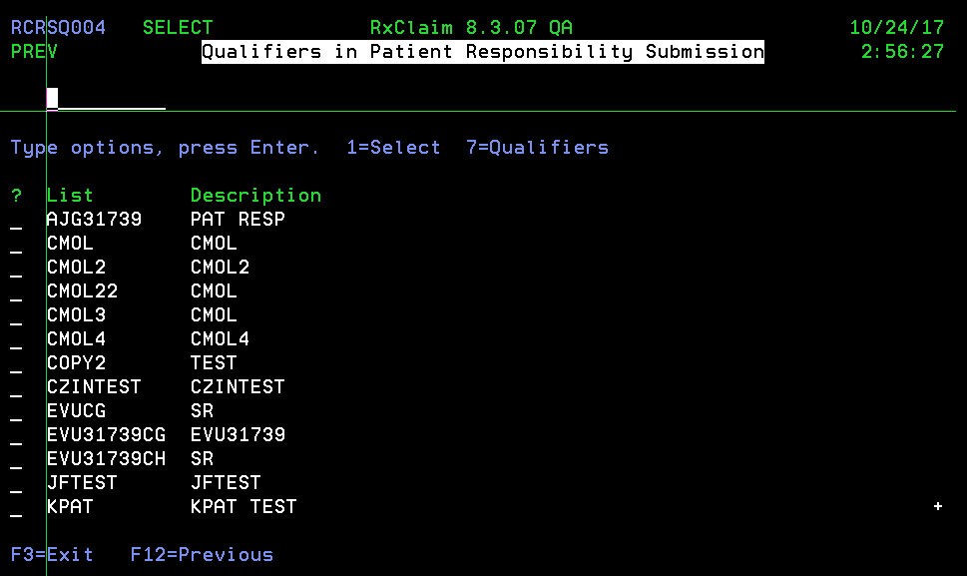

Select screens provide users with a database list from which they select individual record for inclusion into specified entity.

### Detail

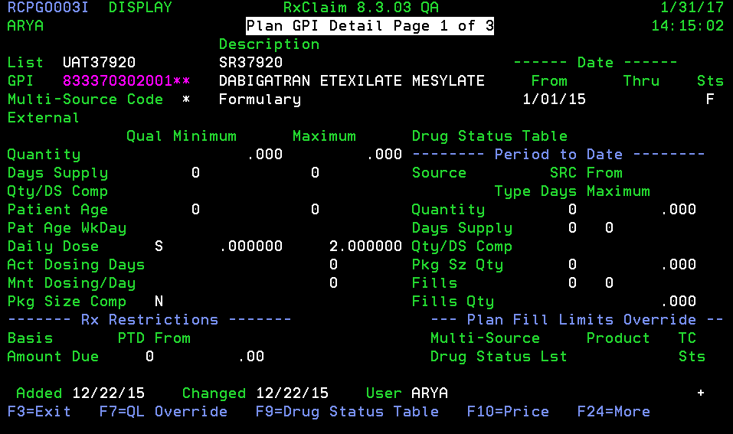

Detail screens provide access to the fields of a record. Depending on how the user accesses the screen (i.e. in Add, Edit, Display or Select mode), the screen mode field in a header will show respectively Add, Change, Display or Select as indicated on the screenshot above. Detail screen can have up to 3 pages that the user can scroll through by pressing **Page Down** and **Page Up**.

### Pop-Up

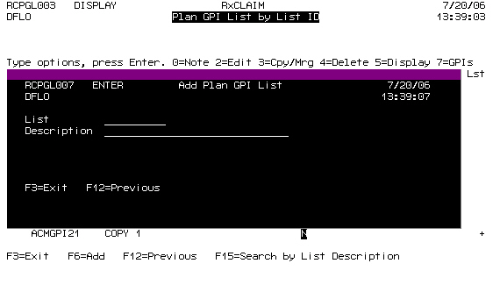

Pop-up windows are being used to display small pieces of information or to prompt a user to confirm an action (see **Confirm Prompt** below). Developers should use Pop-up windows when there are four (4) fields or less on the screen (excluding audit fields).

### Copy/Merge



Copy/Merge screens are special function screens that help users copy lists of records or individual records to new lists or merge with existing lists. When the user wants to create a new list from the source list, they type a new list name. When they want to merge, they select the list to which they want to merge by pressing **F4** in the **List** field. In addition to the list name and description, the screen may include additional parameters as shown in the example screen above.

Additional rules apply for the files that are based on date roll logic. For a simple copy function, only the active records are copied over. Records are copied over without using the roll logic functionality to avoid deactivation of date ranges.

For the merge functionality, the roll logic rules are applied. Details of the rules followed in Date roll logic functionality are explained in section N.N

N.N Date Roll Logic Rules:



### Confirm Prompt

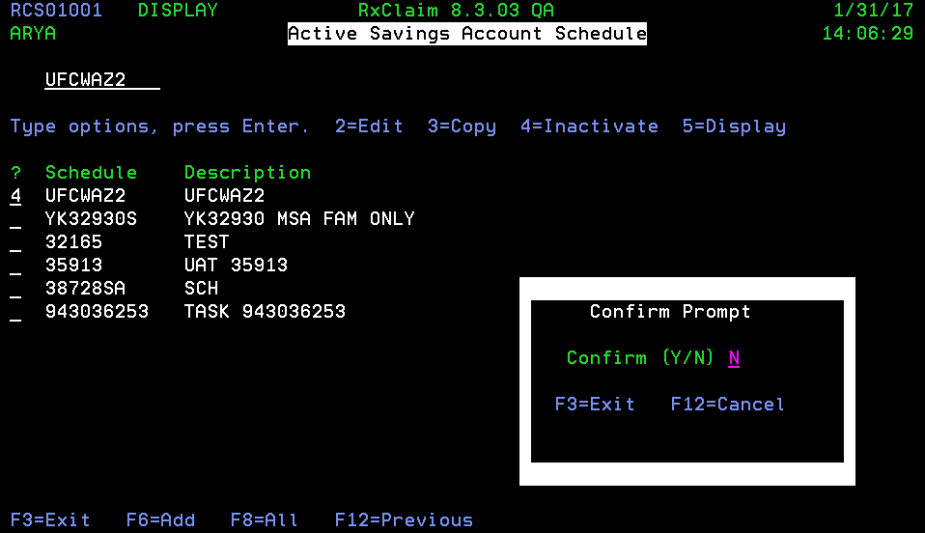

Confirm prompt is a special pop-up window that intended to make sure users commit to an action that will make a change in a database (specifically, inactivate or delete records).

### Multi-Line Display

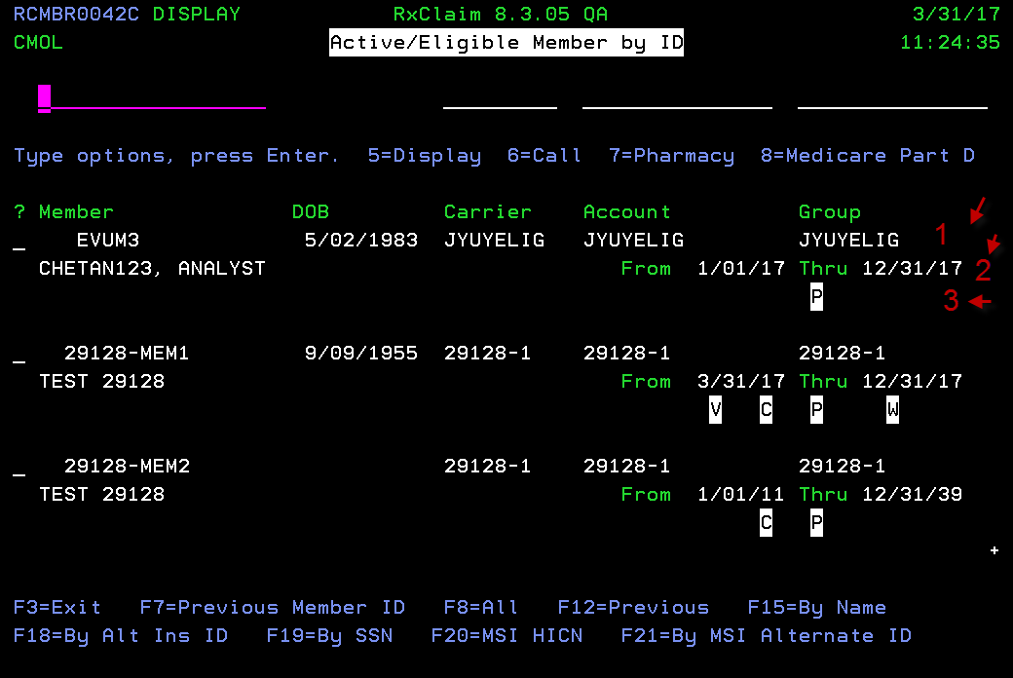

This can be a search or select screens, such as Member Search

GUI

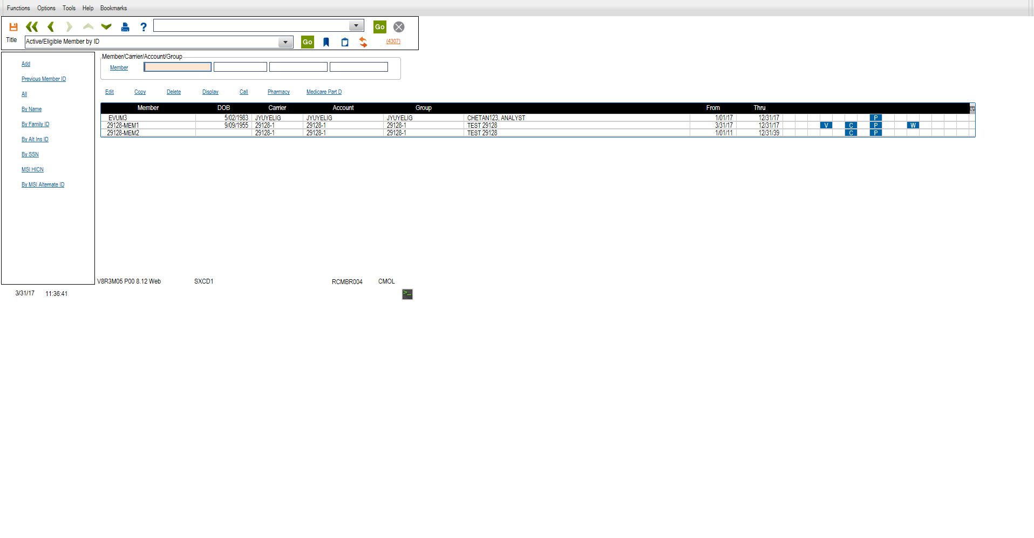

Avoid using multi-line Display file with multi-line information. This causes extended grid in GUI with no column headings. If this is unavoidable, make sure that the fields either have proper field title or corresponding help text.

## Colors

System standards include guidelines for screens and menus.

### Screens

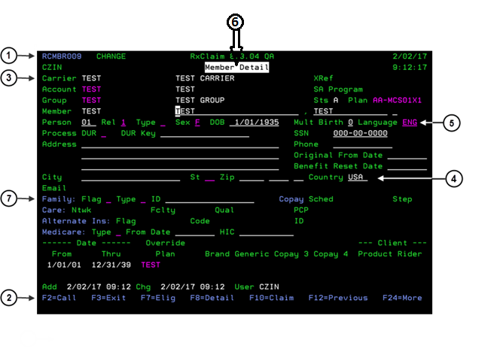

Developers should use the following standards to design screen colors:

|  |  |  |
| --- | --- | --- |
| **Example #** | **Element** | **Color** |
| 1 | Program IDs | Blue |
| 2 | Function keys/Option values (i.e., **2=Edit**, **5=Display** & F3,F12 etc) | Blue |
| 3 | Field headers | Green |
| 4 | Field values (unless they support **F4** functionality) | White |
| 5 | Fields supporting **F4** (hot key) functionality | Pink |
| 6 | Screen titles | Black on white with reverse video background |
| 7 | Field titles is followed by a colon (:) | Blue |
| *Not Shown* | All horizontal (full and partial) and vertical dividers | Blue |

### Menus

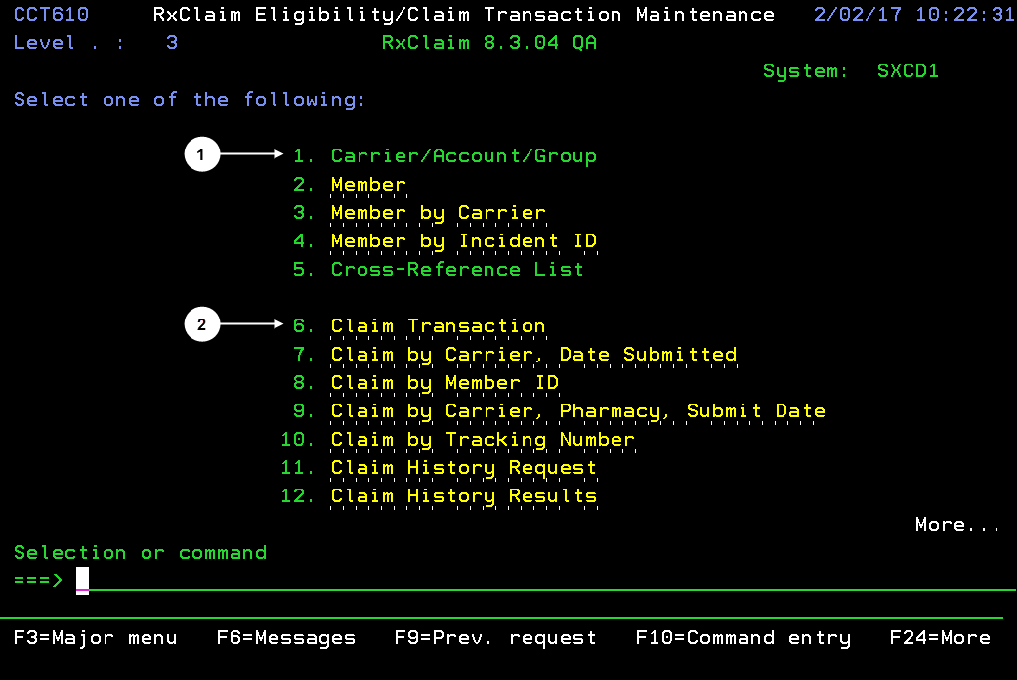

Developers should use the following standards to design menu option colors:

|  |  |  |
| --- | --- | --- |
| **Example #** | **Element** | **Color** |
| 1 | Options that link to other menus | Green |
| 2 | Options that link to a selected program or screen. | Yellow (also amber or  gold) with dotted underline |

### Screen/Program Naming Convention

Here are the program naming conventions that currently in use, Ending:

* 001 – Main Screen (display file – normally active records – if applicable)
* 001I – Inquiry version of 001
* 002 – Add Record
* 003 – Edit Record
* 003I – Display Record
* 004 – Select Record
* 005 – Copy/Merge Record
* 008 - All records – corresponds to the 001
* 008I - All records – corresponds to the 008

If a program end in “I” for Inquiry, all programs called from this point should also be “I” versions.

Depending on the Function keys that call another screen, the program name should follow the function key,

Example:

F16=Search by Name – RCXXX016

F8=All for this set, I prefer to call it RCXXX016A for All, but we can discuss if there are any other options

Prompt screens such as Batch screens – Program names start with P for Prompt

Payment programs start with PB, there may be others, need to check with Janet Reuter

* RxInterACT – Starts to RA
* RxAuth – Starts with AU
* RxParallel – RL, R0
* RxClaim – RC
* Comm – CM
* RxBuilder – RB
* RxServer – RS
* MTM – TM
* BMS – BM
* RxRisk – RK

## Options

Select screens include numbered record options that the user applies to an individual record in the records list. These options are placed above the record list and below the search field(s).

**Standard guidelines for options:**

1. When listing the options at the top of a screen, separate each option with two spaces, unless screen real estate only permits one space.

Example: **0=Note**[space][space]**1=Select**

2. List each option in numerical ascending order from left to right, moving to the next line if necessary. If possible, do not use double digit options. Options 0-7 are reserved for the following values:

|  |  |
| --- | --- |
| **Option** | **Notes** |
| **0=Note** | This should always be the first option. |
| **1=Select** |  |

|  |  |
| --- | --- |
| **Option** | **Notes** |
| **2=Edit** | When this option is selected on an inactive record, a message, “Cannot edit inactive record.” With the record highlighted. |
| **3=Copy** or **Copy/Merge** | No confirm prompt  Copy/merge is used when the record contains child records.  Only active records will be copied/merged. |
| **4=Inactivate** or **Delete** | There should be referential integrity check. Do not allow deletion if the record is used/attached to any records. If there is a 4=Delete option, there should be an F11=Delete option in the record detail. Delete/Inactivate requires a Confirm prompt (RCPMT001). When Deleting Multiple records, Confirm prompt should be shown only once. If record has child records, the child records are also deleted. |
| **5=Display** |  |
| **6=Call Tracking** |  |
| **7=***(Description of the item in plural form).* Examples: **7=Steps**,  **7=Codes**, etc. | Exception to the plural rule: **7=Detail**  and **7=Criteria** (singular) |
| **9=Correction -> 0=Notes to 0=Note** | It should never referred as Notes  Additional Comments:  After typing the option, the cursor should jump to the next record |

7 and up –

Usually used for child records. The number should correspond to a function key in the record detail.

e.g,. 7=Codes -> F7=Codes, 8=Schedules -> F8=Schedules

Options **8** and above are open.

*Example:* The screen below should have **0=Note** as the first option rather than **2=Edit**.

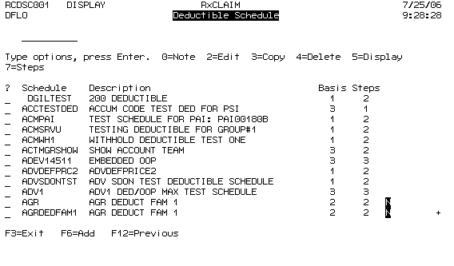

3. While using functions **Inactivate** or **Delete**, the system should display the

Confirm Prompt after pressing **Enter** as shown below:

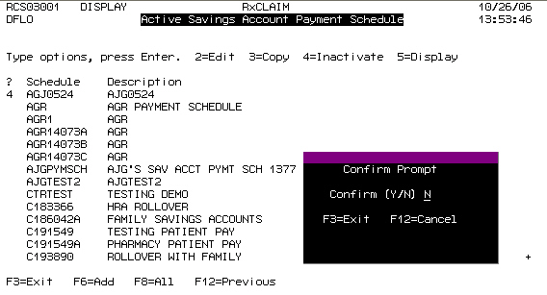

The window background is blue. The **Confirm Prompt** title is white. The **Confirm (Y/N)** label is green. The field value line is pink and supports **F4** functionality. The **F3** and **F12** function keys are blue.

The default value is always **N** for No. When the user presses **F4** on the pink field, the system opens the select window shown below:

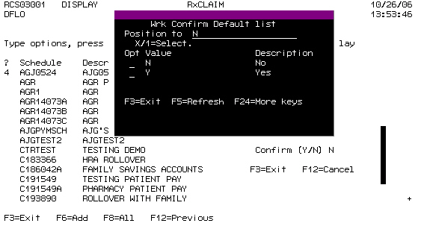

Note the following about the Confirm Prompt:

* If the user does not change the default value **N** and presses **Enter**, then the system closes the **Confirm Prompt** window closes and the does not save changes to the record. However, the detail record remains on the screen with all data already entered.
* If the user types a **Y** for Yes, then pressing **Enter** is NOT required and the system updates the record immediately.
* If the user deletes or inactivates multiple records, display only one

**Confirm Prompt** window to process the request for all marked records.

4. Do not add the **5=Display** function on notes since only one line is allowed and the system can display the whole note on the screen when the user displays the file.

5. If record selection options require a second line, make sure that the second line is left justified like the first line. In the example below, **7=Prior Auths** should be moved all the way to left.

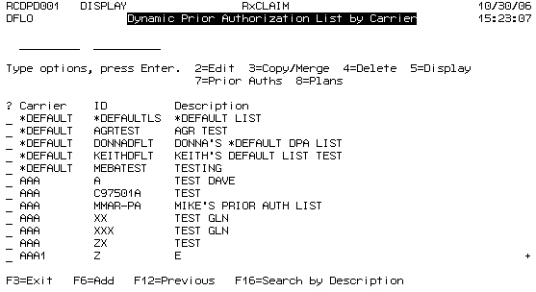

6. If the user attempts to inactivate an inactive record, display the following message: “**Record is already inactive.**”

7. When performing a Copy/Merge, the user cannot use duplicate record keys.

If the user attempts to do this, display the following error message: “**From and To fields cannot be the same.**”

8. All Select screens have the options **1=Select**, **5=Display** and, when applicable, **7=(Description of the items)**. The program mode description (Edit, Display, Select) should not be included in screen title. Exceptions: “**Add**” and “**Copy**” are allowed in the screen title.

9. If the screen has the following functions, allow the user to access the feature from **both** the Select screen and the edit/display screen:

|  |  |
| --- | --- |
| **Select Screen Option** | **Display/Edit Screen Function** |
| **0=Notes** | **F14=Note** |
| **6=Call Tracking** | **F2=Call Tracking** |
| **4=Delete** | **F11=Delete** |
| **7=(Description of Item)** | **F7=(Description of Item)** |

**Example–Select Screen:**

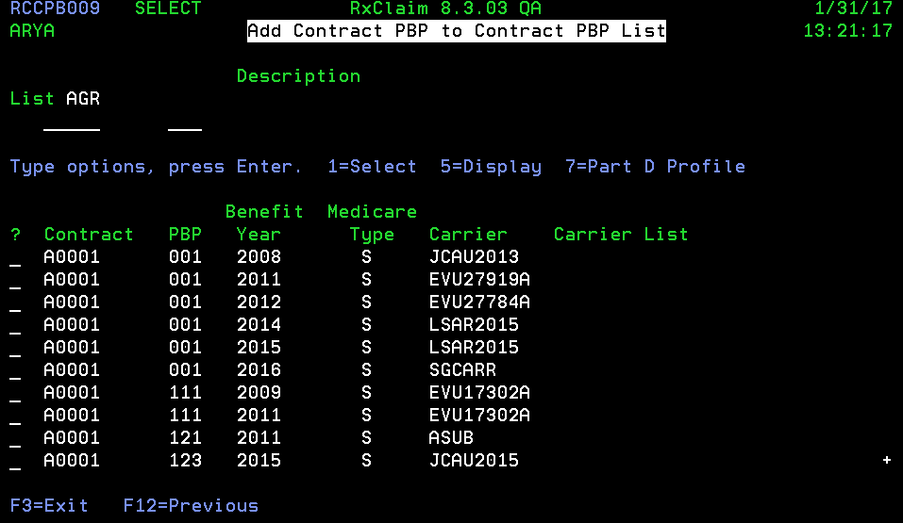

**Example–Display/Edit Screen:**

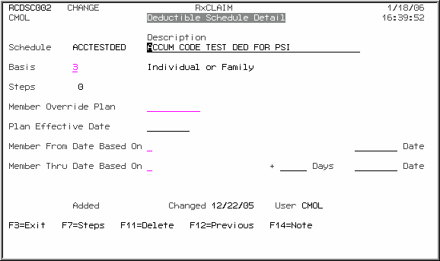

10. Screens that use the **F8=Active/All** option should also have an option **4=Inactivate** displayed when displaying either active or all records as shown in the examples below:

**Incorrect:**

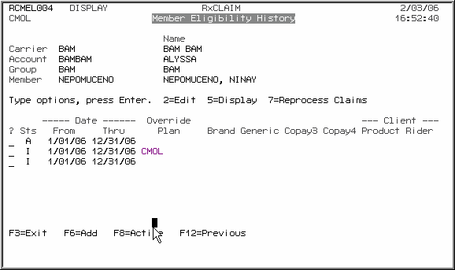

**Correct:**

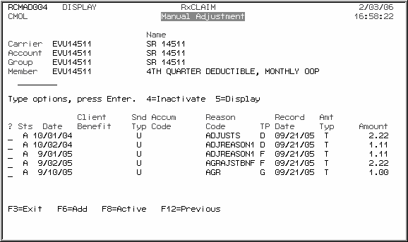

## Functions

Similar to options, function keys control specific tasks. This includes tasks that require navigation to previous screens, adding records, and alternative search options.

**Standard guidelines for functions:**

1. Unless screen space requires fewer spaces, separate each function key listing with three spaces. Never use less than two spaces.

*Example:* **F1=Help**[*space*][*space*][*space*] **F2=Call Tracking**

2. If only two spaces can be allotted, consider assigning a function key to open a new menu that accommodates several functions.

3. Provide **F1** On-line help for all fields. If the field is a status field, display the list of values when **F1** is pressed, particularly if there was no narrative provided.

4. List each function in alpha-numerical order from left to right, moving to the next line if necessary. Keys **F1** through **F15** are preferred for the following values:

|  |  |
| --- | --- |
| **Option** | **Notes** |
| **F1= Help** | Does not appear on screen |
| **F2= Call Tracking** |  |
| **F3= Exit** |  |
| **F4= Hotkey** or **Prompt** | Does not appear on screen. |
| **F5=Refresh** | Does not appear on screen. |
| **F6= Add**, **Submit**, **Submit to**  **Batch**, or **View** (in Notes) |  |
| **F7=** *(Description of the item in plural form)*. Examples: **7=Elig**,  **7=Dates**, etc. | Exception to the plural rule:  **7=Detail** and **7=Criteria** (singular). |
| **F8=All**, **Current**, or **Active** | This function acts as a toggle. |
| **F11=Delete** |  |
| **F12=Previous** or **Cancel** |  |
| **F13=Fast Exit** | Does not appear on screen. |
| **F14=Note** |  |
| **F15=Search by Name** or **Search by Description** | Applies to Search screens. |
| **F16=Search by Number** or **ID** | Applies to Search screens. |
| **F24=More** | Use to toggle between function lists. |

5. When creating an **F4** select function, allow input on the search field so it positions to the closest record matching what the user typed in the field. For example, when a user presses **F4** on a field that has a value of **XYZ**, the system should take the user to the select screen equal to or greater than **XYZ**, rather than positioning the search to the very top of the file.

6. All the function keys on a screen that call a sub file (such as contingent therapy or price override from an NDC record) should be displayed even if the file supporting the fields on the screen has not been created yet. If the user presses a function key that acts on a sub file, the system should add the record automatically before executing the function without requiring a confirm prompt.

**Incorrect:**

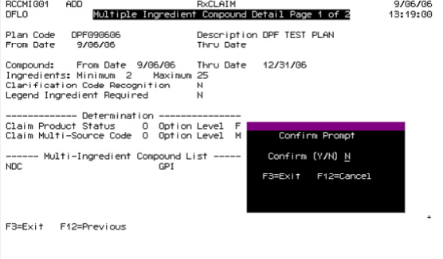

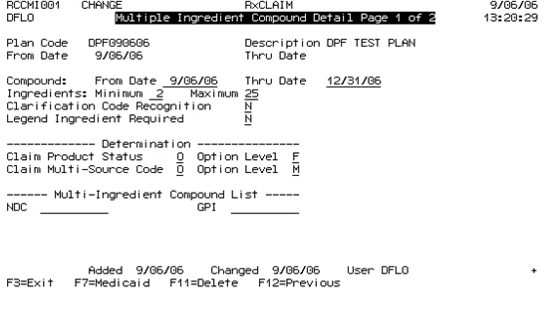

For example, the Multiple Ingredient Compound Detail Page incorrectly withholds some function keys until the user confirms creation of the sub file:

## Headers and Titles

System standards for headers and titles cover items such as screen headers, column headings, and repeated display fields on multiple-page screens.

### Screen Headers

All screens, including popup windows, (but excluding menu screens, F4 selection screens, and confirm prompts) include two lines of header at the top that display the following system data:

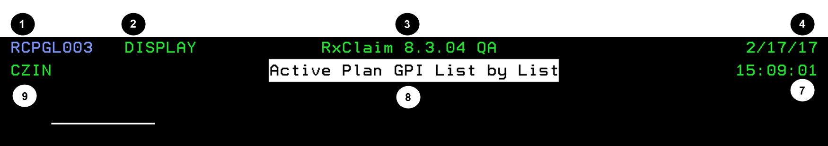

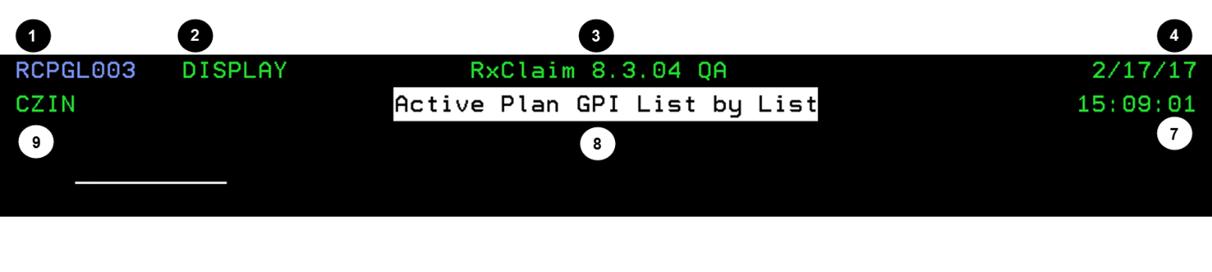

|  |  |  |  |
| --- | --- | --- | --- |
| **Example #** | **Element** | **Description** | **Location** |
| 1 | **Program ID** | Unique identifier associated with the program that controls each screen. | Top row, upper left corner. |
| 2 | **Screen mode** | Identifies the state of the current screen. Modes include **ADD**, **SELECT**, **DISPLAY**, **ENTER**, and **CHANGE**. | Top row, upper left, right of Program ID. |
| 3 | **System name** | Identifies the OptumRx product (i.e. RxClaim, RxMax, RxPortal, etc.) | Top row, center. |
| 4 | **System date** | The date provided by the AS400 server. | Top row, upper right corner. |
| 9 | **User ID** | The User ID of the current user. | Second row, upper left. |
| 8 | **Screen title** | Description of the screen. | In the top center.  Max limit of 50 character for each row. Two rows are allowed for the Screen title, *but* one row is preferred.  *Never* truncate words within the Screen title, abbreviate the words instead, if needed. For example, if you had to abbreviate the word *Status* within a Screen title:   * Correct way – *Sts* * Incorrect way of – *Sta* |
| 7 | **System time** | The time provided by the AS400 server. | Second row, upper right corner. |

### Column Headers

Select screens and screens with multiple records of information use columns to display related information.

**Standard guidelines for column headers:**

1. When a multi-word column header appears on a screen, Column titles should be bottom-justified. The example screen below is incorrect. **Carrier**, **Account**, **Group** and **Identifier** column titles on this screen should be bottom aligned with **Grp**, **Type**, **Ver**, and **Elg Lst**.

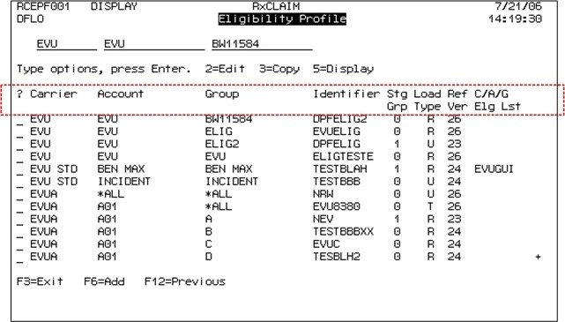

2. As shown in the example below, screens should display column titles even if there is no data for the column fields. To accomplish this, developers should use constants instead of field titles.

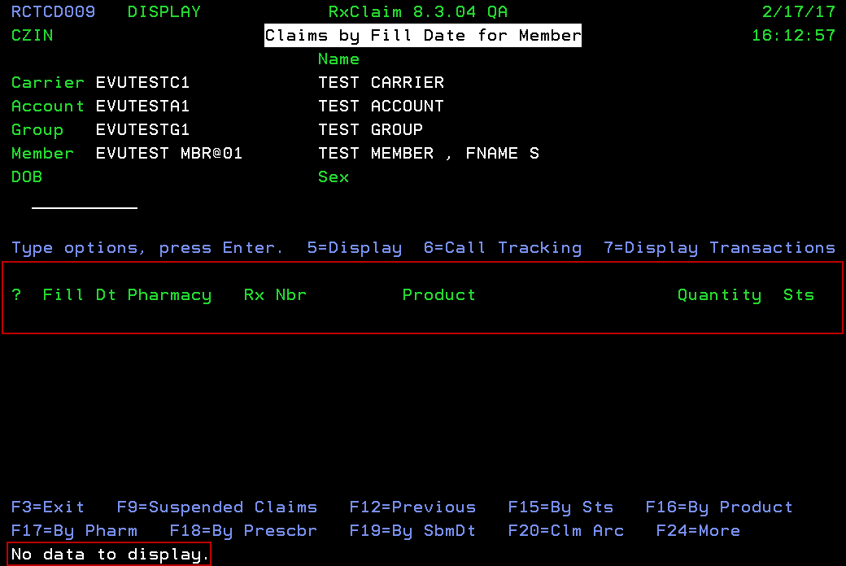

3. When there is no data to display for column fields, the screen should display the message “**No data to display**” as shown above.

4. On the record level, developers can shorten column headings by using general terms. For example, instead of displaying column headings as **Deductible Schedule** and **Acccum Code** use **Schedule** and **Code**, since the screen title already contains the type of records it is displaying.

## Fields

System standards provide guidelines that describe how developers should place and format fields on various screens.

### Common Rules

Common field guidelines include the following:

1. Avoid abbreviating field titles. However, if you have to abbreviate a field due to space restrictions, make sure abbreviations are consistent. In the example below, the word “**Defaults**” is consistently abbreviated to “**Dflts**” when naming functions:

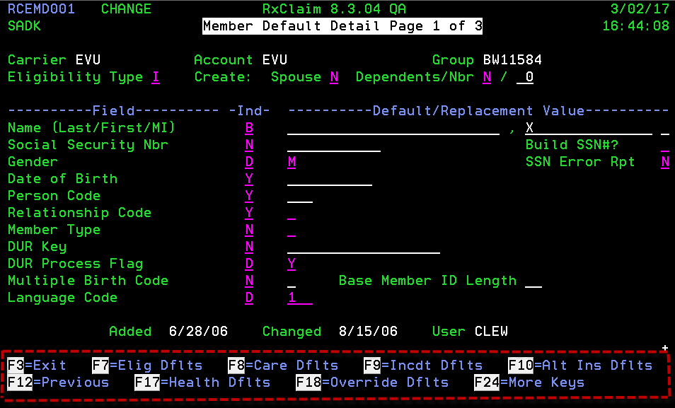

2. Show the full description of the field value unless there is a space issue.

3. Where ever possible, use similar name fields on related add, edit and display screens, and place them in the same position.

4. On Display screens, **F4** selection functionality should be in place when possible, especially when there is a need to view related tables or lists.

5. Remove dots between field title and field value.

6. The first field on the screen should be left justified and not indented. In the examples below, the **Note** field title and field should be all the way to the left.

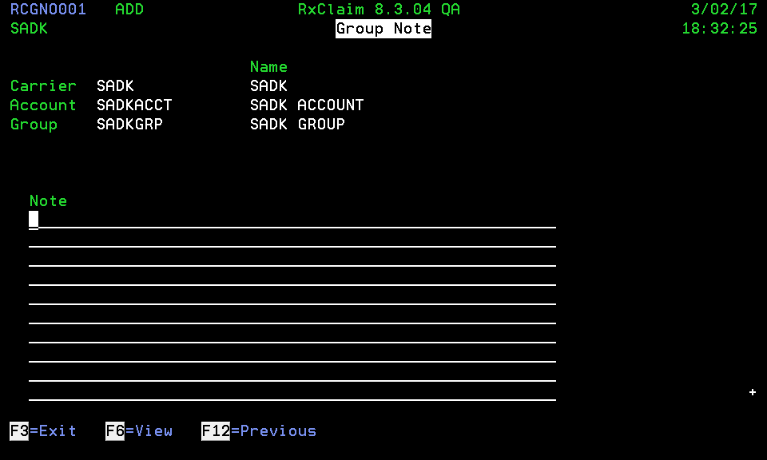

7. This rule also applies to pop-up windows. In the example below, **Schedule** and **Description** should be left justified and not centered on the screen:

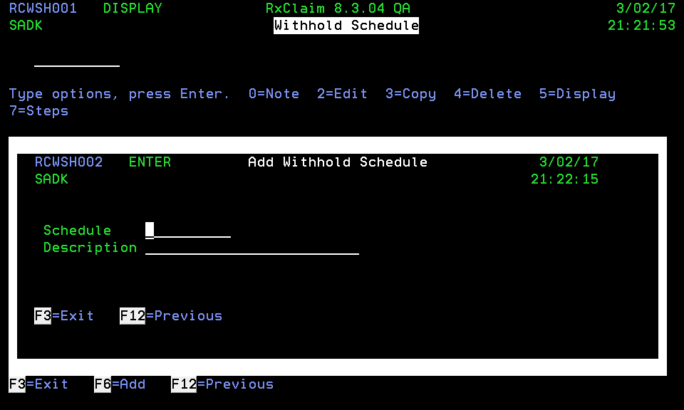

8. All screens should have one blank line between the window title and the search/positioner fields or first title unless there is a space issue.

9. The field description and/or text should default to allow only uppercase unless specified otherwise in the Service Request.

### Numeric Fields

Guidelines for numeric fields include the following:

1. When displaying decimal numeric values on a display file, the column title should be right justified to the last digit (not negative sign).

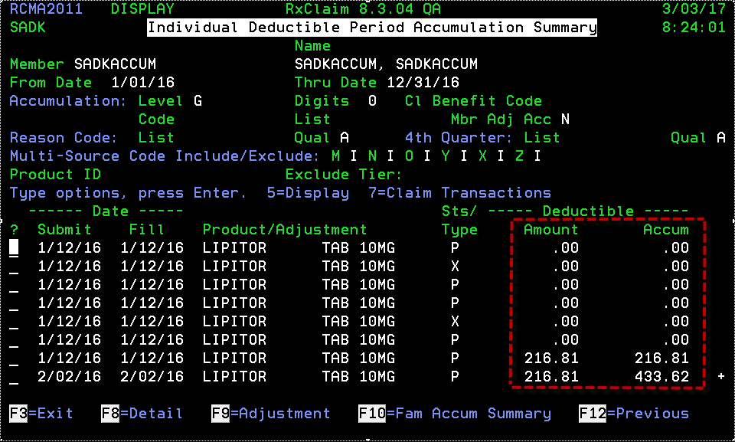

2. If the numeric value represents a count or status, it should be in the center of the field title as shown below:

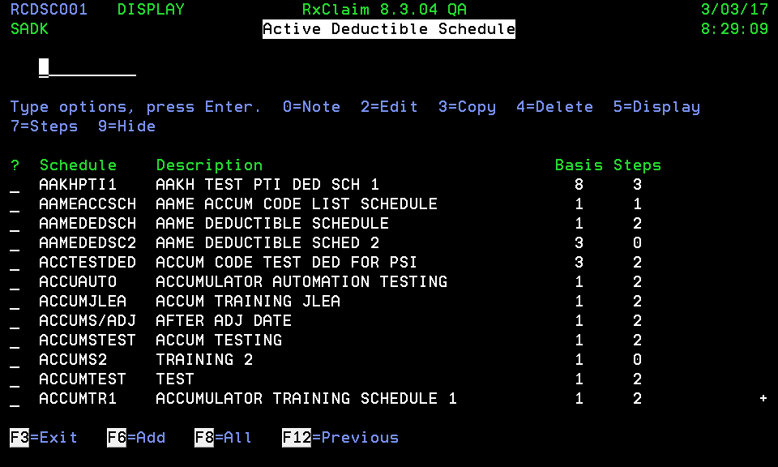

### Date Fields

1. Dates should be displayed as 6-digit date field ( 99/99/99) unless it is a birth date which uses an 8-digit date field (99/99/9999).

2. Label Eligibility date fields **From Date** and **Thru Date** in detail record screens. Developers can also display **From** and **Thru** in column format as shown below:

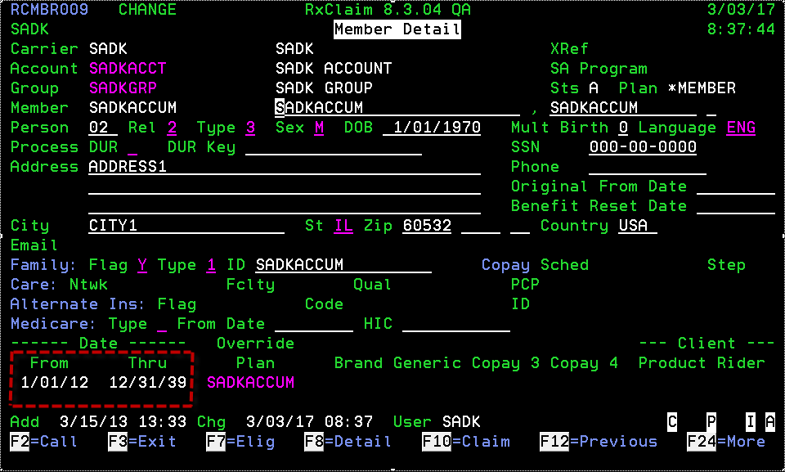

If space permits, “**Date: From Thru**" is also acceptable as shown below:

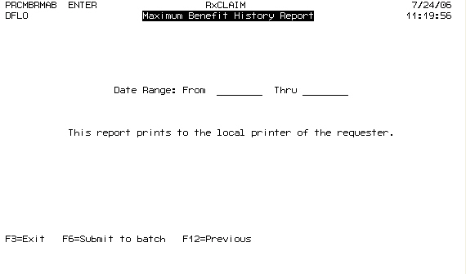

### Record IDs

All records that have an ID will have a corresponding **Description**. The exceptions below, however, have **Names** instead of **Descriptions**.

|  |  |  |  |
| --- | --- | --- | --- |
| * Carrier | * Account | * Group | * Member |
| * Product | * Pharmacy | * Affiliation | * Region |
| * Prescriber * Care Facility | * Payer | * Financial Institution | * Payee |

### Message Code/Type

Use the following guidelines when adding message code and type fields to screens:

1. As shown in the example below, place the **Message Type** below the

**Message Code**.

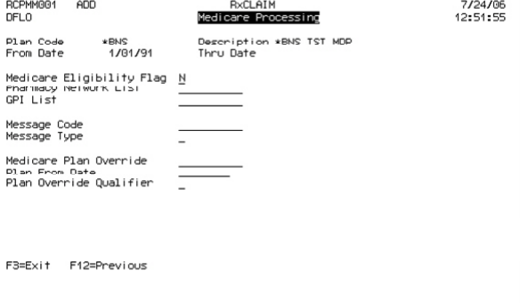

**Incorrect:**

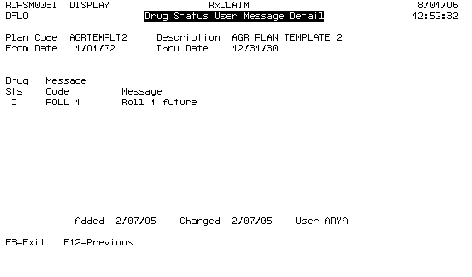

2. On almost all screens, do not provide a message description. This saves space because some messages are very long. Instead of displaying the description, use **F4** functionality in which the user can select/view the message description on a RCMSG type screen.

**Correct**

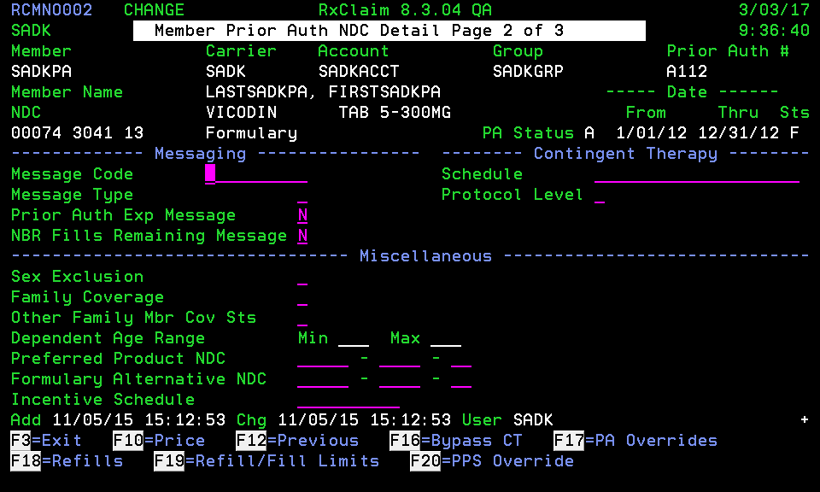

3. The only file where the description is displayed is in a RCMSG type screen as shown below:

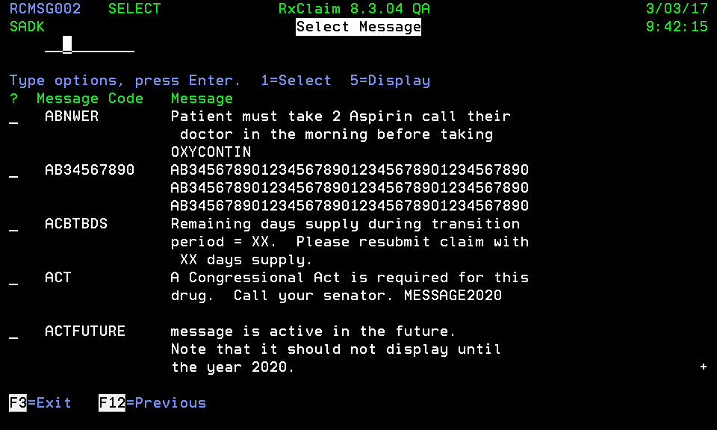

### Multi-Page Screens

Developers should use the following guidelines when designing titles and fields that appear on multiple screens:

1. Screens having more than one page should display a plus sign (**+**) at the lower right corner of the screen on each page except for the last page. The plus sign informs the user to press the **Page Down** key to view additional screens.

Add a title to screens with multiple pages that displays both the current page number and the total number of pages (see example below).

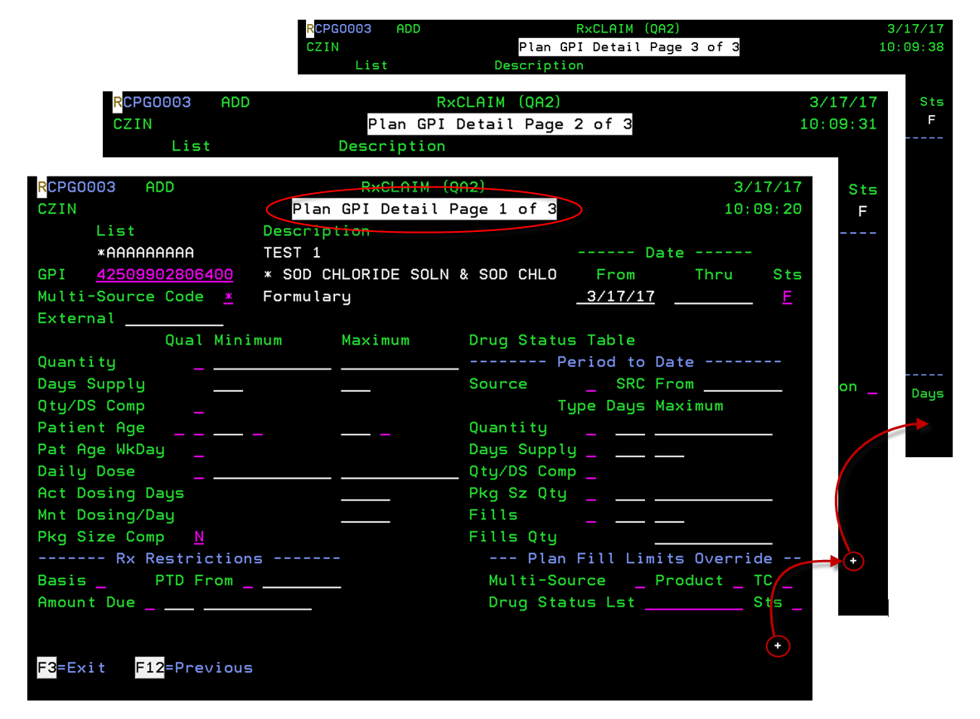

1. Common screen fields displayed on multiple related screens should be located in the same position on all screens. Notice the first and second screens below have the exact location for Carrier and Name, but the third screen shifted up. The third screen should be consistent with the first and second screens.

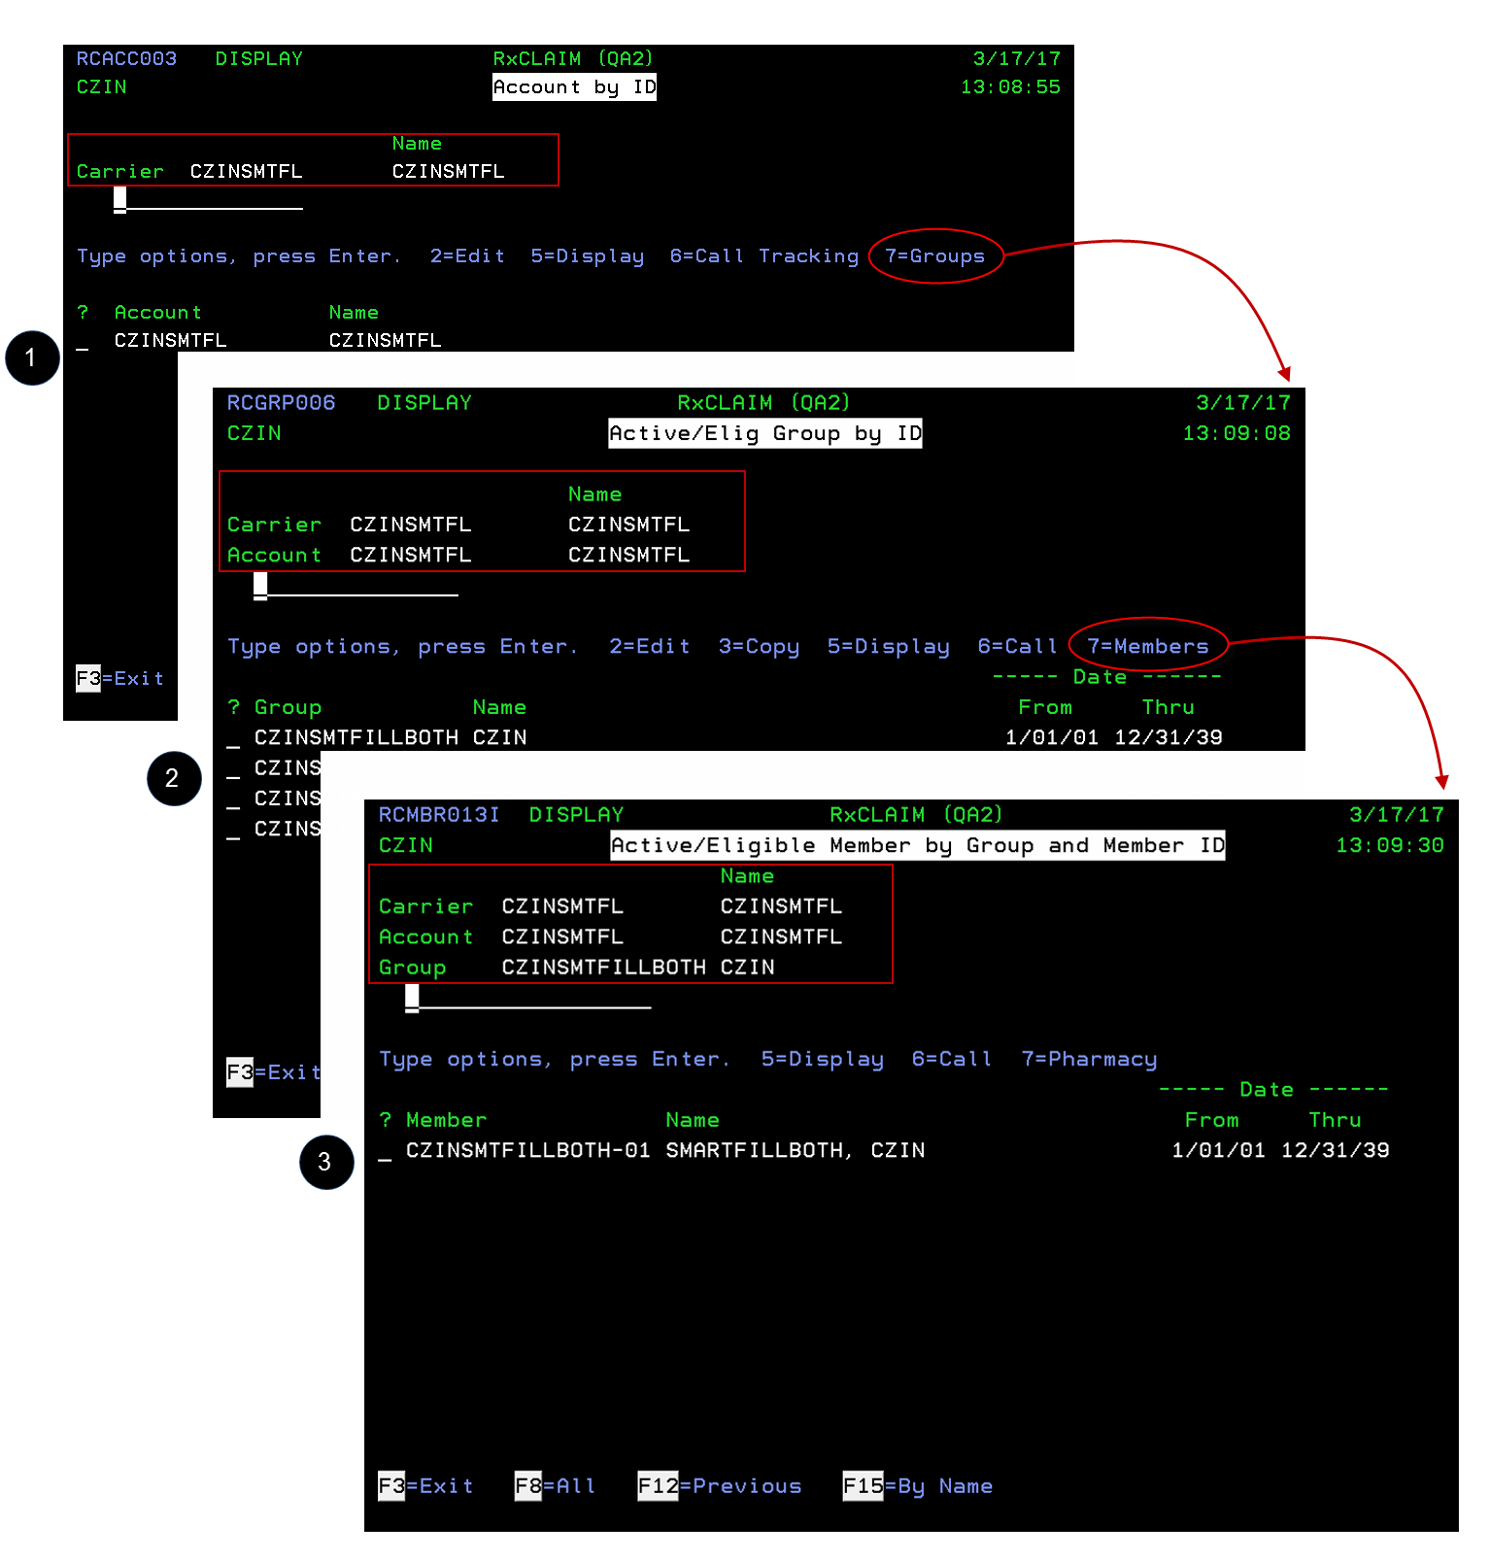



### Sort/Positioner Fields

Developers should use the following guidelines when using sort fields (also called “positioner” fields):

1. Sort fields/positioners do not have field titles.

1. Align sort fields/positioners with the corresponding columns as shown below:

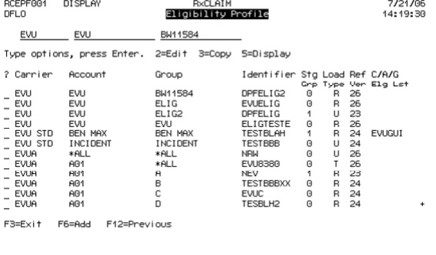

### Audit Fields

Edit and display screens should display audit fields that include **Added** date,

**Changed** date, and **User** ID as shown below:

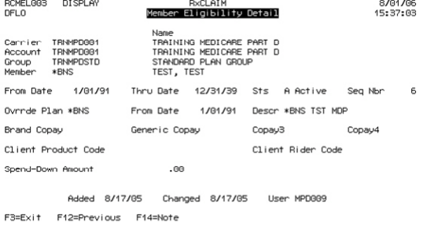

User the following guidelines when setting up audit fields on a screen:

1. Spacing for the audit fields should be as follows:

|  |  |
| --- | --- |
| **Field** | **Spacing** |
| **Added** | 13 characters from left of screen |
| **Changed** | 4 characters from the end of the **Added** date field. |
| **User** | 4 characters from the end of the **Changed** date field. |

2. Provide a blank line between the audit fields line and the function key line.

3. Do not include audit fields for screens in add mode.

4. If the **Added** date is not available, center the **Changed** and **User** fields.

5. Provide one space between field title and field value.

### Copy/Merge Screen Fields

Copy or Copy/Merge screens should provide a **Description** field if applicable. If the type of record is included in the window heading, the field title should not contain the description of the record. For example, in the screen shown below, the title identifies the type of record (**Medicaid Product View List**), so the Copy/Merge field titles only include **List** and **Description**.

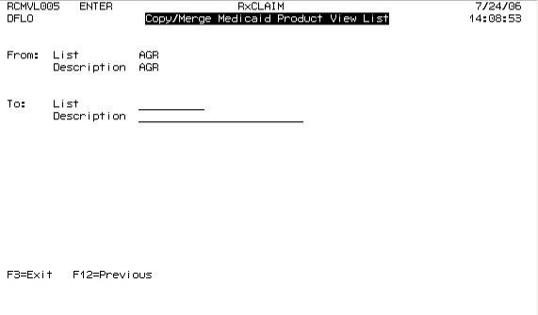

### Multi-Source Codes

When displaying Multi-Source Codes, the sequence should be **M N O Y X Z** as shown in the example below:

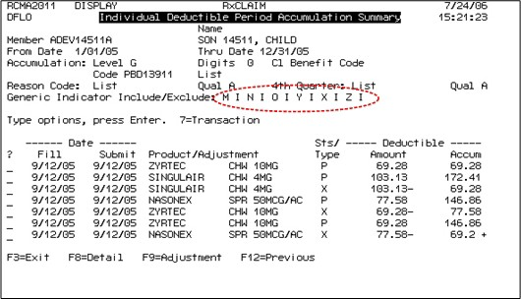

### Record Detail Screens

When designing an add record screen, field titles should be on the left of the input field rather than above. Having the title above the input field makes the screen look like a record selection screen (see examples below).

**Correct:**

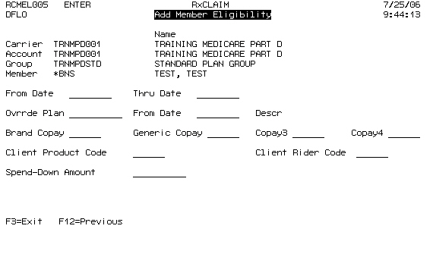

**Incorrect**

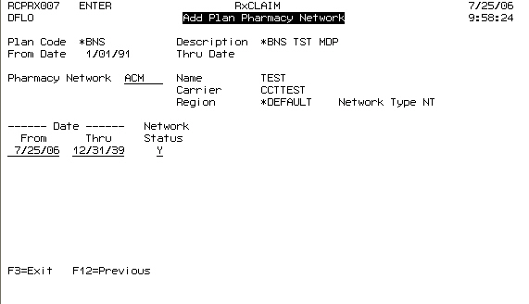

### Status Fields

Follow these guidelines when displaying status fields:

1. When a function has a capability of inactivating a record, always display the status of the record in the detail screen.

2. Status field should default to **Active** and display-only mode during an Add function.

3. The status field should be located as the last field of a displayed record. The examples below show the correct and incorrect placement of the status field:

**Correct:**

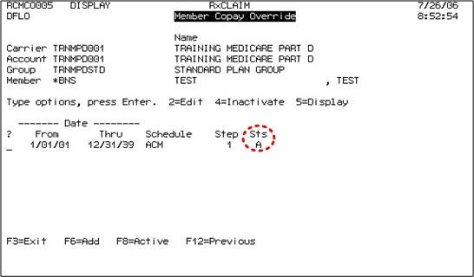

**Incorrect** 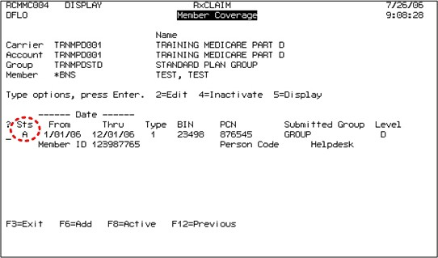

**Incorrect:**

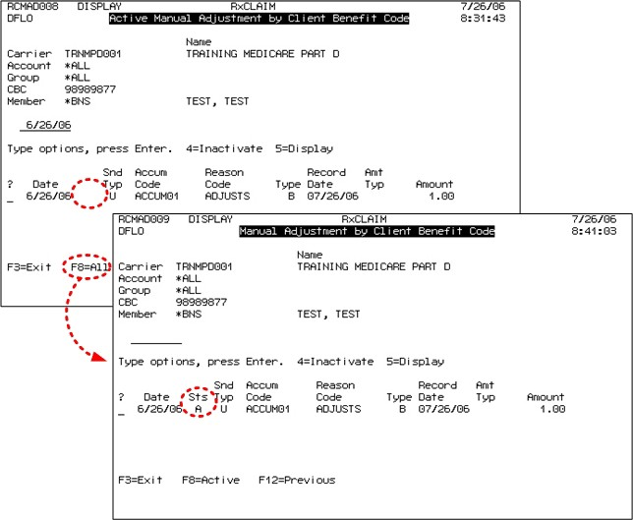

1. Status or any Valid values List field should not have *blank, blank as one of the value.

### Report Fields

The values for the break field on report screens should always be selected from the following possibilities:

|  |  |
| --- | --- |
| **Field** | **Definition** |
| **N** | No, do not perform page break |
| **P** | Page Break |
| **Y** | Yes, perform page break |

Developers can add additional text to Fl help text to clarifY the meaning of these values, but do not reverse the meaning of "No" and "Yes" (i.e. "Yes, no Page Break").

### F1 Help Text

For Status Fields, Synon generates a default help text based on the condition values.

For Example:

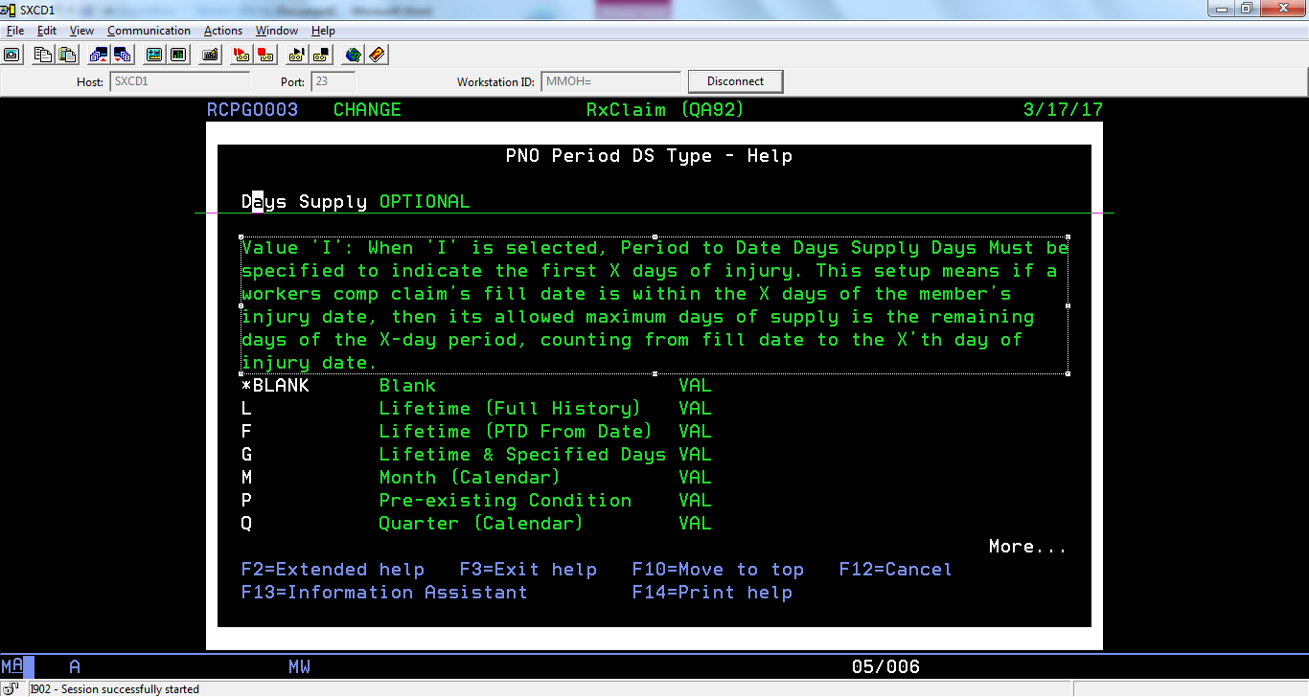

In the above screen, the selected portion is manually entered help text whereas the listing of condition values is the default help text, generated by Synon.

Often times, the FRD only includes the help text that is a detailed description and does not list the condition values as per the default help text. The manually entered helptext must match the one given in FRD, word to word.

Usually in Synon, new fields are not defined for every screen. The fields belong to files and all screens referring to that field on the file will have the same default help text irrespective of what condition values are valid for that screen.

### Field Validation

1. After pressing F4 on a field to select a record or a value, other fields that have not been reached yet should not be highlighted with “Value required” message.
2. In batch programs, we need to make a decision whether the “F6=Submit to Batch” should be displayed or nor since this text already appears on the function key line already. If we decided to still display this message, a validation should be made so that this message would only appear when all required fields are entered. Currently, programs using this message display the message after the first field is populated. This gives an impression that we are ready to submit and we are not.
3. When validating fields, make sure that the fields causing the error should be highlighted. For example, Price Schedule not found, price schedule field should be highlighted. There are times when a field with the same name appear multiple times and we could not tell what is required. Similarly, “Value required” message is often displayed but we need to let user know which field is required by highlighting the field.
4. When deleting a record, verify that the record selected is not used, e.g. deleting price schedule may be attached to a price table.
5. BA/SA needs to specify if the value of a free text field needs to be validated for record existence or not, e.g.,
6. Carrier – must contain valid value
7. From Carrier – any free text value allowed

### Indicators

1. Indicators should be reverse image.
2. New indicators should be added to the left rather than to the right.
3. When creating indicators, use/create an indicator field rather than a text/literal that lights up.  We can add help text on actual field, while we cannot add Help Text to text/literals.
4. Help Text on Indicators is a mandatory in the FRD. When there is no Help Text on indicators, we will not be able to know what the indicator represents.

# Program Behavior

## Search Behavior

Follow these system standards when coding search behavior:

1. By default, records are sorted by ID (Member ID, Product ID, etc.).

2. Search/positioner fields should occupy the left-most columns on the screen.

3. The first (leftmost) search field should return a list of records that are equal and greater than the search string. For example, if the user types “**A4H**” as shown below, the system returns all matching records and records greater than the search string (i.e. **A52210**, **A9613M**, **A9926**, etc.)

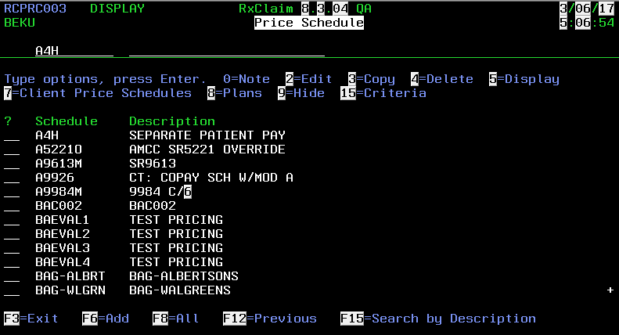

4. When the user types a value in a succeeding search field, the system should only display records that include (i.e. are equal to) the entered string. In the example below, the user typed “**AMCC**” and the system returned the following:

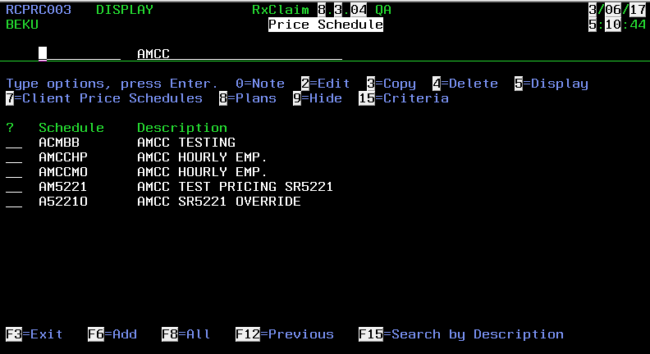

5. Return only active records for each new type of search.

6. Within the same menu option, retain search line values on the initial screen when moving from one type of search to another search, and then back to the initial screen.

*Example:*

|  |  |
| --- | --- |
| c | The user enters an ID on the search line of the **Pharmacy** screen. |
| d | The ID was not found, so the user then opens the **Pharmacy By Name** screen and searches based on name. Again, the name is not found. |
| e | The user then presses the **F12** key to return to the **Pharmacy** screen. On the **Pharmacy** screen, the ID that was originally entered on the search line should still be on that search line. Also, the last accessed record should be placed in the sort/positioner field after exiting the detail record screen. |

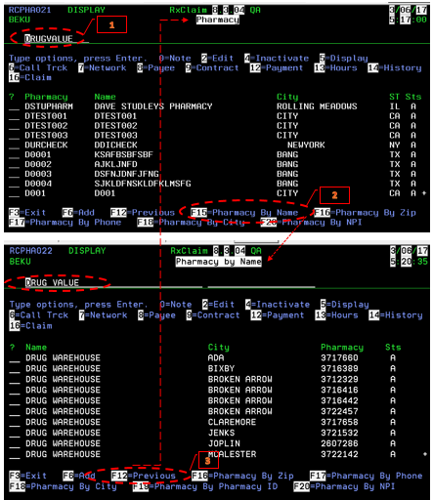

## Selecting and Auditing Records

Use the following guidelines when coding procedures to select and add records:

1. Avoid combining add and edit in one screen/function.

2. When a user types a value in the record selection field, the cursor should automatically advance to the next record selection field.

3. Rules for handling the record detail screen:

ƒ Except for parent records, if the user adds a new record and saves it, the record detail screen should close and display the select screen with the new record on top.

ƒ If the user edits an existing record and saves it, the record detail screen remains open. However, if roll logic applies to the screen, the record detail screen should close.

4. When adding a parent record, the screen should not exit. The user must be allowed to enter child records while in the add parent screen.

## Deleting Records

When a user types a **4** in a record selection field to delete or inactivate a record, and the system cannot delete or inactivate the record for any reason (such as a record dependency), developers should process the screen as follows:

1. Remove the **4** from the selection field.

2. Display the error message at the bottom of the screen.

3. Move the record the user attempted to delete to the top of the record list.

## Copying Records

When copying a record (such as a plan) with associated records from another file, only copy active records. Do not copy records marked “inactive.”

## Selecting Records

On report selection screens, similar to the screen example shown below, where users have the option to set the parameters of a report using a From/Thru range or a List, make both fields (From/Thru range and List) optional. The user can populate either one or both types of fields.

However, if the user populates ONLY the List field, the Status (Sts) flag (used to indicate if the associated list is an “include” or “exclude” list) must be **(E)xclude** or **(I)nclude**.

If the user does not populate the List file and populates ONLY the From/Thru range, the Status flag should default to **A** (all). List

If the user populates a From/Thru range *AND* a List field, the Status flag with either option **(E)xclude** or **(I)nclude** is required. When the system uses the From/Thru range, the From/Thru range takes precedence before it checks the list.

Then the system checks the lists to either include or exclude what is on the list and what has already been selected based on the From/Thru ranges.

For a Status of **(I)nclude**, a specified range with a specified List will only display relevant data found in both the From/Thru range and the List.

For a Status of **(E)xclude**, a specified range with a specified List will exclude relevant data found in both the From/Thru range and the List.

**Status Flag determination for List:**

|  |  |  |
| --- | --- | --- |
|  | **FOUND IN LIST** | **NOT FOUND IN LIST** |
| **I(nclude)** | SELECT Data Record | DO NOT SELECT Data Record |
| **E(xclude)** | DO NOT SELECT Data Record | SELECT Data Record |

**Example when using From/Thru range, List, and Status:**

|  |  |  |  |
| --- | --- | --- | --- |
| **Data Records w/in From/Thru range**  ***(From A Thru F)*** | **Data Records w/in the List** | **Sts** | **Outcome** |
| A, B, C, D, E, F | A, B, C | I | A, B, C |
| A, B, C, D, E, F | G, H, I | I | *BLANK* |
| A, B, C, D, E, F | A, B, C | E | D, E, F |
| A, B, C, D, E, F | G, H, I | E | A, B, C, D, E, F |
| A, B, C, D, E, F | *No List used* | A | A, B, C, D, E, F |
| A, B, C, D, E, F | G, H, I | A | Screen validation Error |

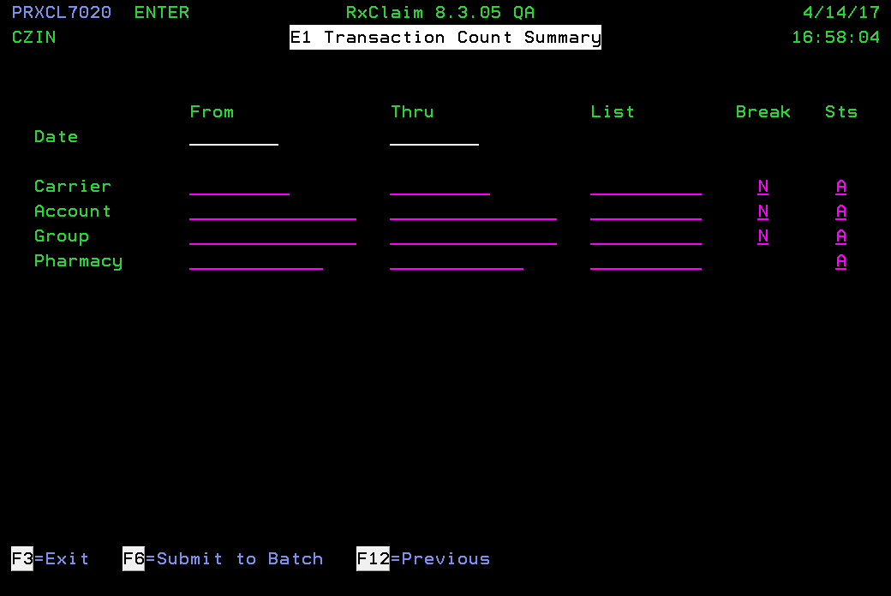

# Messages

Use the following guidelines when designing messages:

1. Avoid using abbreviations unless there is a space issue.

2. Avoid using contractions like "Can't".

3. Do not use “Do you wish,” “Please,” etc. when displaying messages or on prompt screens.

4. Messages should follow regular sentence structure, including punctuation marks. If the sentence includes the name of the field, capitalize the beginning of the field name(s). Example: “**Accumulation Code cannot be entered when Add Subsidy Adjs = N**”

5. As shown in the example below, highlight the field in error when sending an error message. If a screen has multiple pages, include the field name in the error message, since it may not be possible to highlight the field.

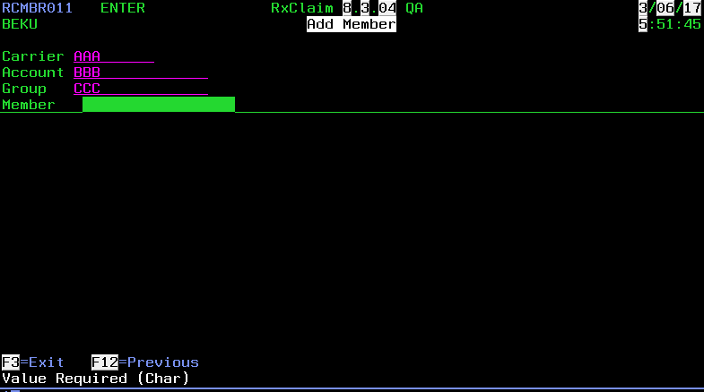

6. Synon generated messages for “**Not Found**” and “**Existing**” should be modified to expand the full name of the field and/or record. For example, “**FN1 Frmlry Notice List not found**” should be changed to “**Formulary Notice List not found**.”

# Spelling

Use the following spelling for these words, acronyms, and phrases:

1. Cannot.

2. Mutli-Source.

3. Medi-Span.

4. Out of Pocket – no dashes in between.

5. TrOOP.

6. Subtype.

7. “not valid” rather than “invalid”.

1. e-prescribing.
2. Use “gender” rather than “sex”.

# Trademarks

* RxClaim
* RxInterACT
* RxAuth
* RxParallel
* RxRisk
* RxServer
* Therapy Management
* RxBuilder

# Document Change Log

This document has undergone corrections/additions. The table below tracks significant changes to the document.

|  |  |  |  |  |  |  |
| --- | --- | --- | --- | --- | --- | --- |
| **Date of**  **Request** | **Name of**  **Requestor** | **Person Making Change** | **Date Change Made** | **Section Title** | **Change** | **Reason** |
| 09/29/06 | Alex Ryabov | DFLO | 03/22/07 | *2.6.1 Common*  *Rules* | Added rule for uppercase default applied to field description and/or text. | To document current practice. |
| 02/05/07 | Alex Ryabov | DFLO | 03/22/07 | *3.5 Selecting*  *Reports* | Added text to clarify how the From/Thru range and Include/Exclude flags interact. | To document current practice. |
| 03/30/2017 | Andrea Aloni on Behalf of Standards Committee |  | 03/30/2017 | *Entire Document* | Updated document to fit standards of 2017. |  |
| 10/13/2017 | Alex Ryabov/ Cecille Molenda /Punith Revanna | Punith Revanna | 10/13/17 | *2.2.1 Screens*  *2.2.2 Menus*  *2.3 Options* | Updated the screenshot of Select screens to reflect proper screen. |  |
| 10/25/2017 | Cecille Molenda /Punith Revanna | Punith Revanna | 10/25/17 | *Added 2.6.16 Indicators. Updated 2.6.12* | Added rules for Indicators. Added condition for status and valid values List. |  |